JK00 Kerry [Half-Picture] Series [1901?]

Ph Charles Kerry
Pu Kerry & Co.
F Photograph is printed in blue on left-hand third of card only with title and words 'Kerry & Co., Sydney. Copyright'. Probably published in1901
All cards are H format, but pictures of H format are turned on one
edge. Thus, details of format below refer to the Picture format only. Back is
undivided but with two printing styles as noted below.

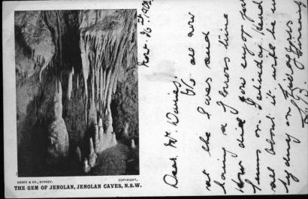  Right: The two different formats of the back of these cards. | 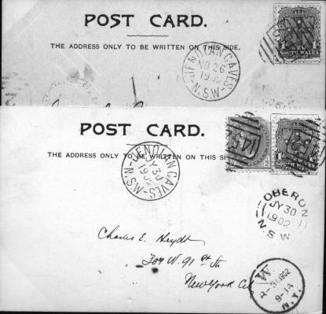

- Letter 'S' in 'Post Card' extends below other letters JK00A
- Letter 'S' in 'Post Card' does not extend below other letters JK00B

JK00A.1 Crystal Palace, Jenolan Caves, N.S.W. V
JK00A.5 The Gem of the West, Jenolan Caves, N.S.W. V [pm.27 Jul.1903]
JK00A.6 The Gem of Jenolan, Jenolan Caves, N.S.W. V [Jenolan pm.26
Nov.1902]

JK00B.2 Nellie's Grotto, Jenolan Caves, N.S.W. H [pm.1911]
JK00B.3 Wilkinson Grotto, Jenolan Caves, N.S.W. H
JK00B.4 Entrance to Gem of Jenolan, Jenolan Caves, N.S.W. H
[Jenolan pm.30 Jul.1902]
Posted to New York city; sender says “Greetings from the Interior of the Earth”
JK00B.7 The Grand Stalactites, Jenolan Caves, N.S.W. V
JK00B.8 The Crystal City, Jenolan Caves, N.S.W. H

